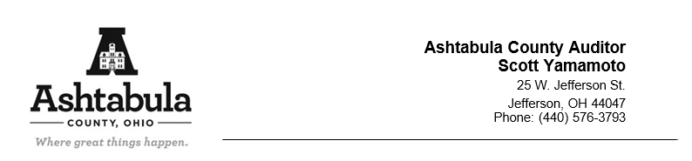
Ohio Board of Tax Appeals
30 East Broad Street
Columbus, OH 43215

RE: Waiver of appearance

This letter serves as notice of Ashtabula County waiver of appearance and intention to stand on the record for the following hearing:

2025-887 AFLI3 LLC: Scheduled 02/10/2026

Respectfully submitted,
APRIL R. GRABMAN
PROSECUTING ATTORNEY

By, ___________________________________
CORY C. FUNK (0091021)
Assistant Prosecutor
Attorney for the Ashtabula
County Board of Revision
25 West Jefferson St.
Jefferson, OH 44047
(440) 576-3734

